Software Documentation

1. Software Overview
SOFTWARE COMPONENTS:
OLED BITMAP IMAGE SEQUENCES
SERVO MOTOR LISTS AND FUNCTIONS FOR THEIR MOVEMENT
DIFFERENT CYCLES FOR THE SERVO MOTOR including WALK and DANCE Cycles.
PLATFORMS USED:
Micropython, Bottango, Terminal (for the test of the OLED Display)

The software handles the primary code, importing libraries from machine including i2c,spi and uart protocol logic.
The primary code contains the oled library import with the bin images and the servo controls.

2. System Logic
1.User turns on the switch or plugs in the micro-USB
2. The power supplies 7.4V to a buck converter
3. The DC-DC boost buck convertor steps down the voltage to 5V
4. The signal goes to the DF Player mini to access the files from the micro-SD card that end with .mp3 and plates them sequentially through the connected speaker.
5. The OLED Starts displaying the bitmap image sequences from a preset animation that was created and then converted to this format to be displayed on to the screen
6. The HOME POSITION of the servos gets triggered i.e. the mean position of the servos.
7. The Burst animation is triggered
8. DANCE - animation cycle is triggered - twist, lean , tilt , wave etc.
9. The USB is connected and a walking cycle animation can be played using walk cycle code on laptop that can be adjusted per cycle.
10. Animation ends, music stops , returns back to HOME position.
3.FLOWCHART:
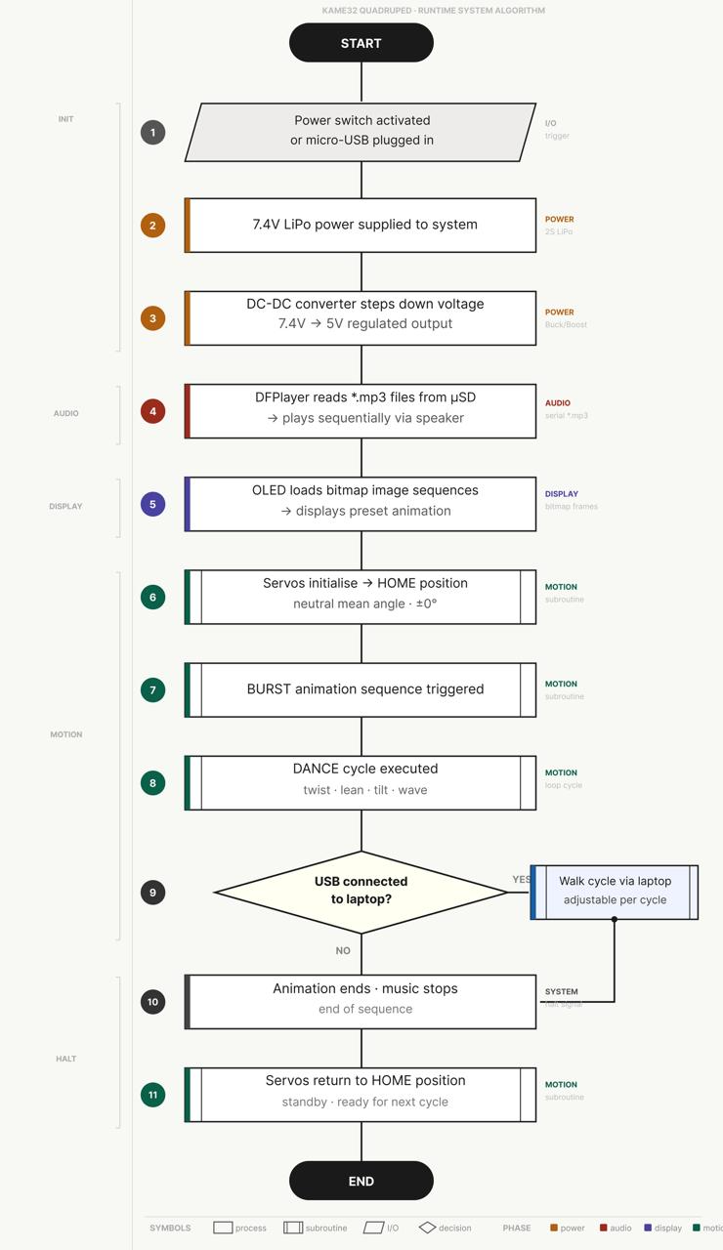

4. App Flow (If MIT App Inventor)

Base MIT App Inventor (Used as a stepping stone to the HTML Website)
- Start Scanning → scans for BLE devices, populates list live
- ListView tap → selects device
- Connect → connects to selected device
- Disconnect → disconnects
- CobraKai / Bob / Wave / Dance → all four send identical byte [1] to the ESP32 (bug — never differentiated, meant to be fixed in html file)
- Clock timer polls for incoming strings, displays them in status label

HTML File
- Start Scanning → opens browser's native BLE picker
- Device tap → selects device
- Connect / Disconnect → same behavior
- CobraKai / Dance / Wave / Bob → each sends a function call

